Milestone 1 Manual Feature Extraction and Matching

Wei-Yuan Su, Kehao Xu

**Manual Correspondences (Across All Image Pairs):** List all manually selected point coordinates across the three images in tabular form. Ensure that each image pair (A–B, B–C, A–C) has at least 10 corresponding points for computing homographies. Note that you need 4 pairs for homography and 8 for the fundamental matrix (with the 8 points algorithm).

1. Points selection of IMG_1223(A)



1. Points selection of IMG_1224(B)

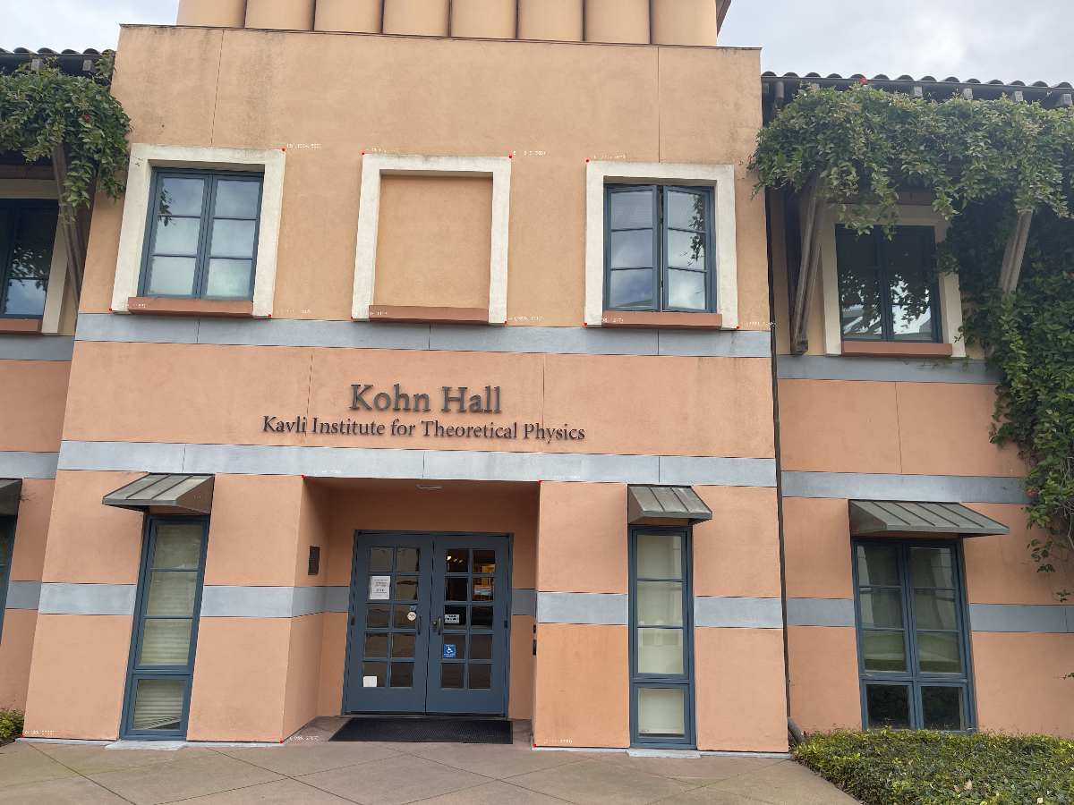

1. Points selection of IMG_1226(C)



**Homography Estimation (Two-View Planar Geometry):**

∗ Estimate the 3 × 3 homography matrix H between selected image pairs using any linear least squares method. While the Direct Linear Transform (DLT) is a standard choice, it is optional for this MS01.

∗ Present the estimated matrix, explain its numerical values briefly, and apply the transformation to map points between images.

∗ Validate the transformation by overlaying the mapped points on the target image and commenting on the alignment accuracy. For this step, choose points that are not used for computing H, pick a few to show the alignment.

1. H matrices

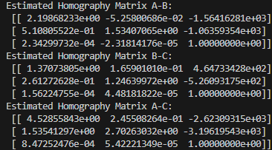

1. Validation of H matrices



**Fundamental Matrix and Epipolar Geometry:**

∗ Compute the fundamental matrix F using a suitable least squares method applied to a set of point correspondences between at least one image pair (e.g., A and B).

∗ Visualize epipolar lines: for each point in Image A, draw its corresponding epipolar line in Image B (and optionally in Image C using a second fundamental matrix).

∗ Provide visual overlays of the epipolar lines and the corresponding points, and briefly discuss how well the points align with the predicted lines. Again, pick points that are not used in computing F.

1. F matrices

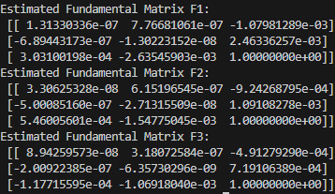

1. Visualization of epipolar lines

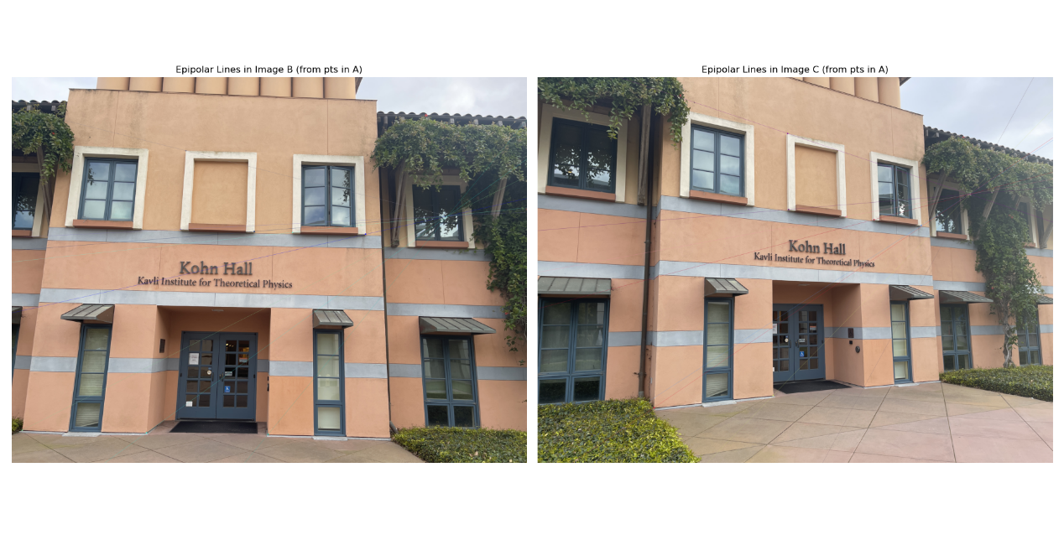

1. Visualization of epipolar lines of new points

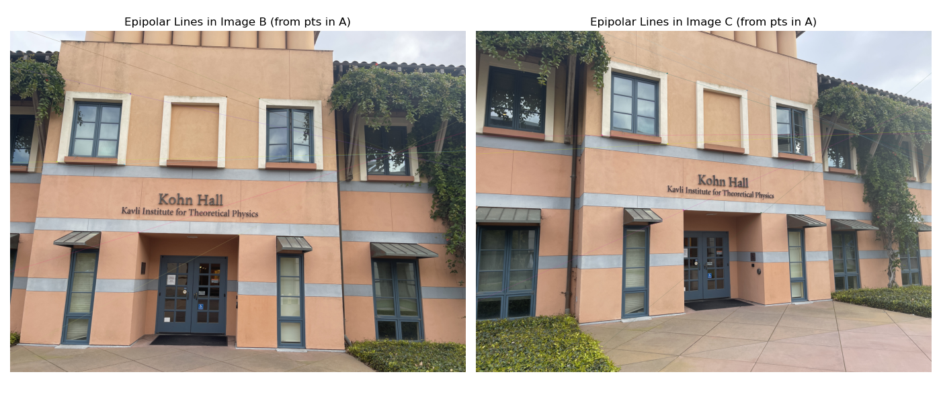

We tested the generalization of F by selecting new test points not used in training and visualizing their epipolar lines. The alignment remained accurate. Slight deviations can be attributed to manual annotation noise and scene depth variations.